**OBJECT ORIENTED AND VISUAL PROGRAMMING**

**REPORT**



**CREATE BY:**

1. **Inria Altje Kalalo**
2. **Sheryl Sharon Kaparang**
3. **Salwa As-Saffa Sahante**

**PRESIDENT UNIVERSITY**

**ACADEMIC YEAR 2024-2025**

1. **STUDENT:**

This is the **Student Management System interface**, displaying a student data entry form on the left and a searchable table of student records on the right, with options to add, update, delete, print, or clear records.

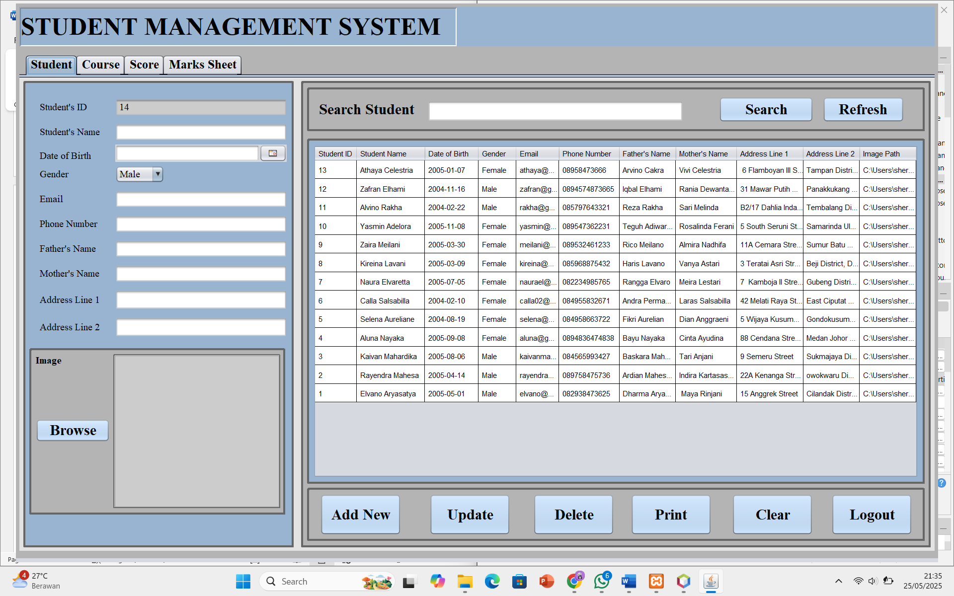

1. ADD NEW

To add student data, all forms must be filled in, no blanks allowed.

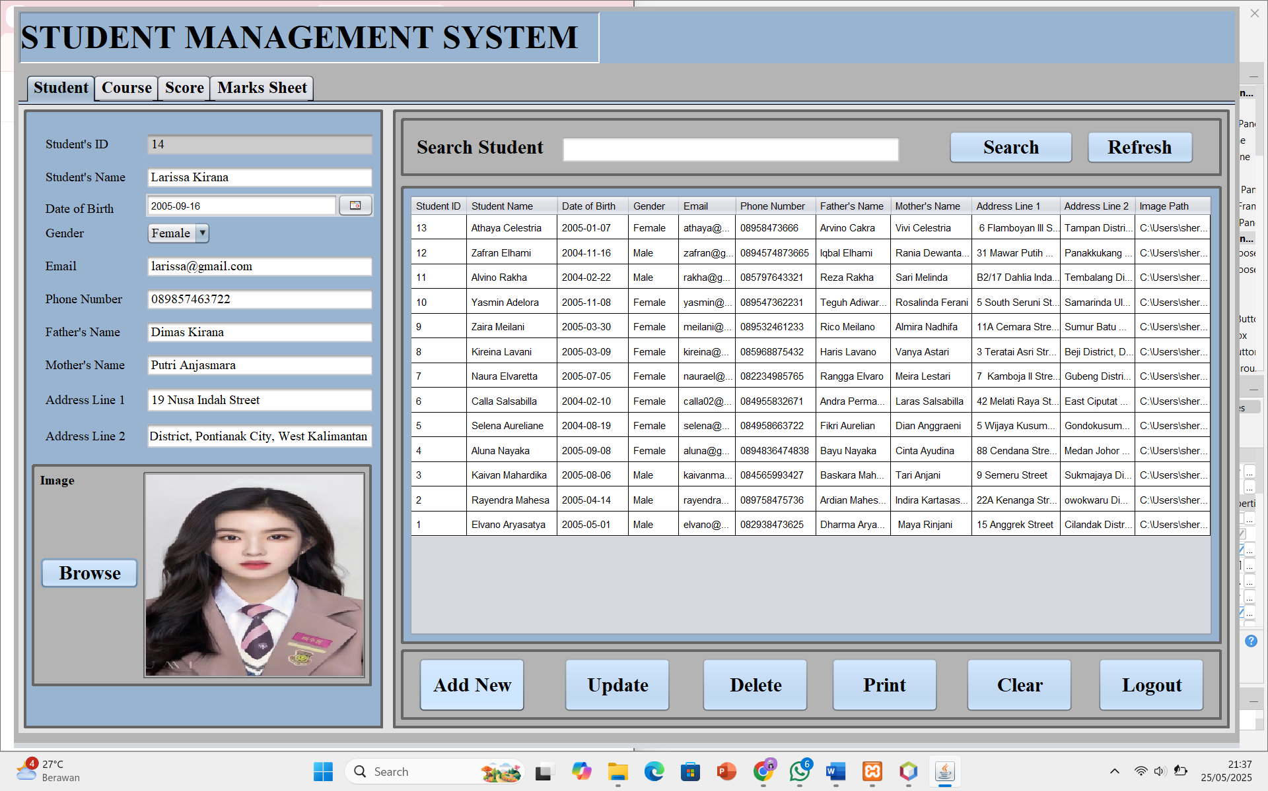

This dialog message will appear if successfully adding new student data.

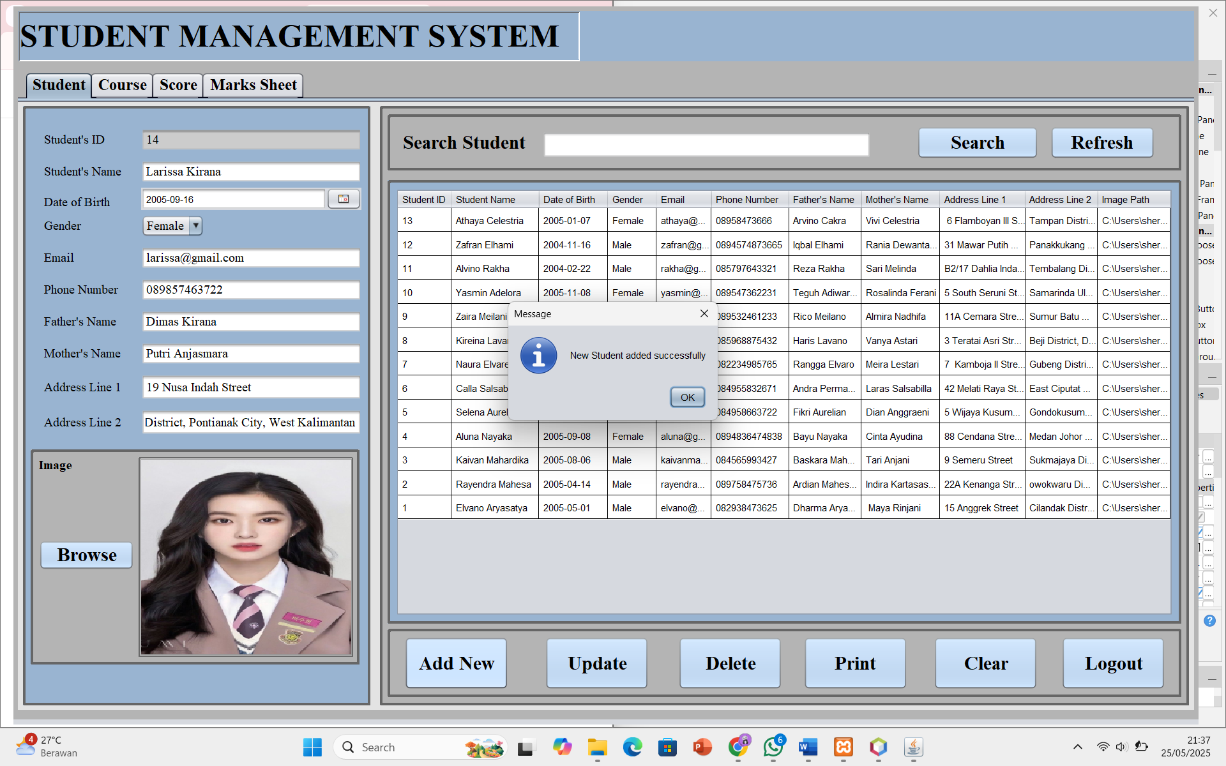

The table will automatically display the newly inputted data.

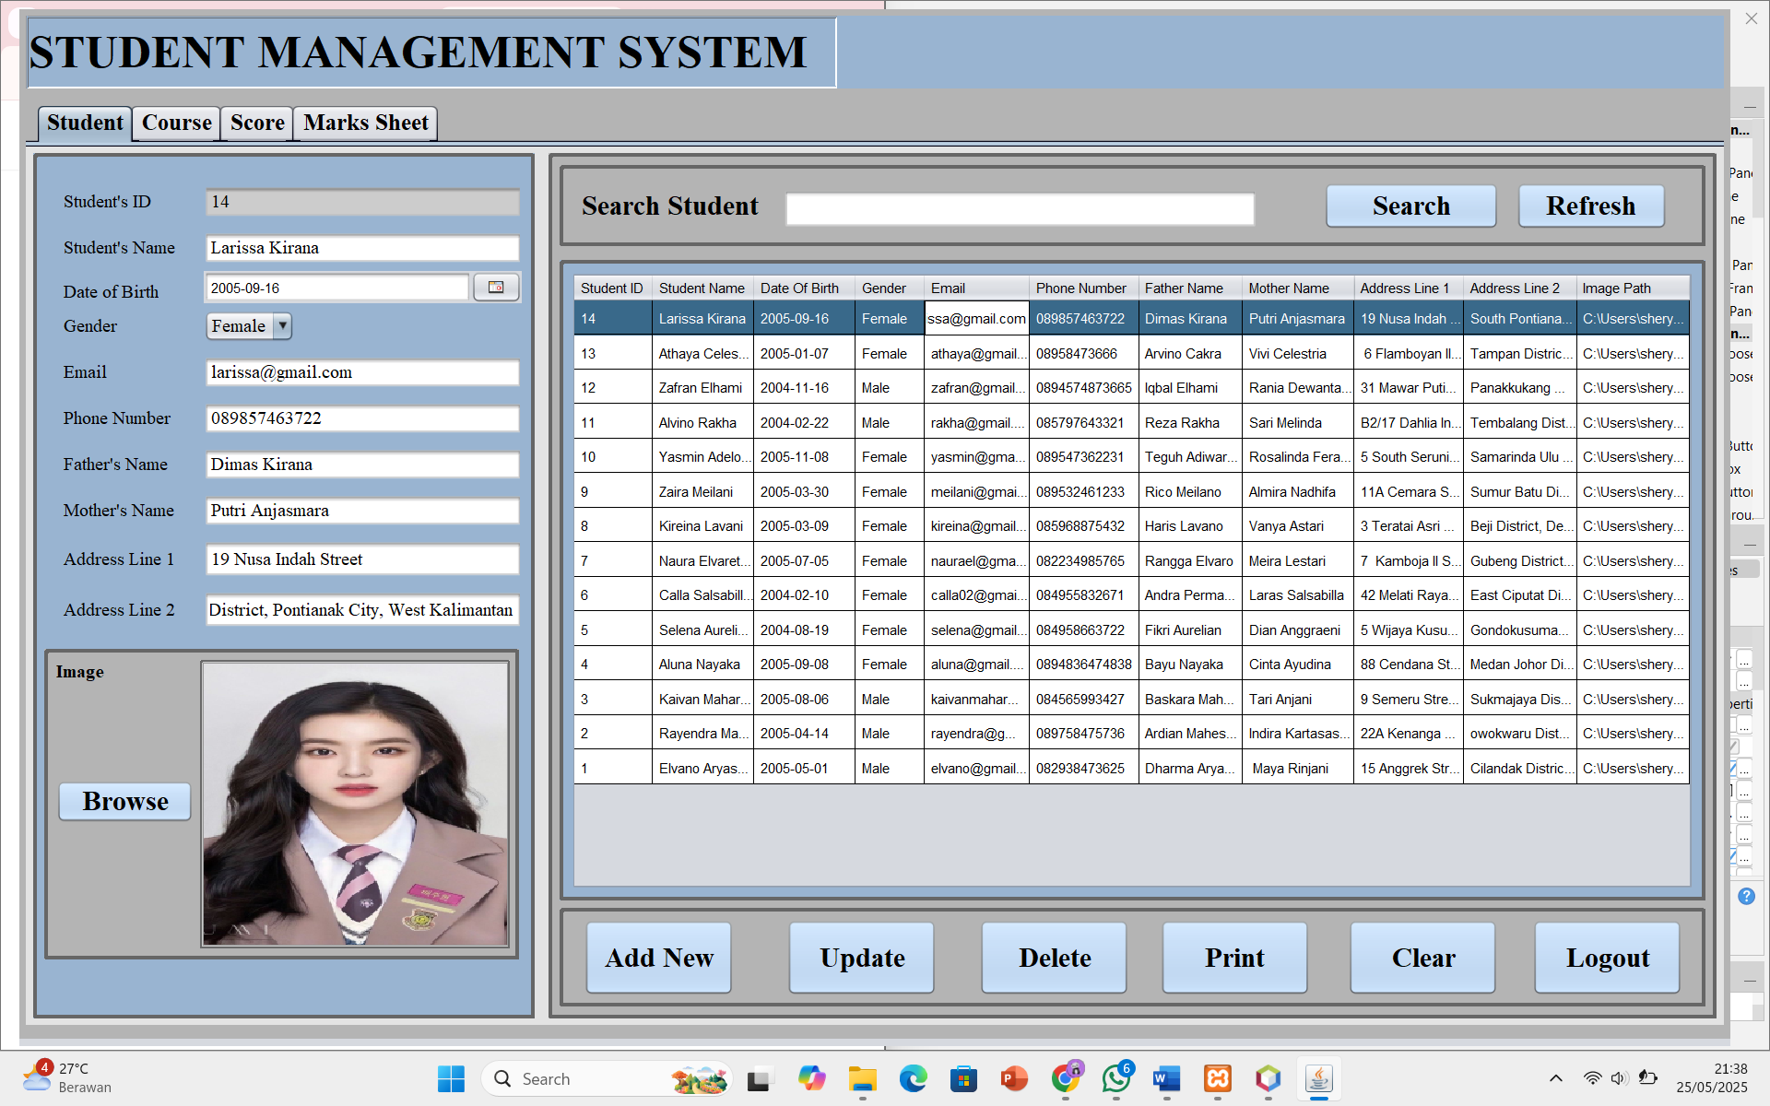

1. UPDATE

There is a feature to change data from existing students.

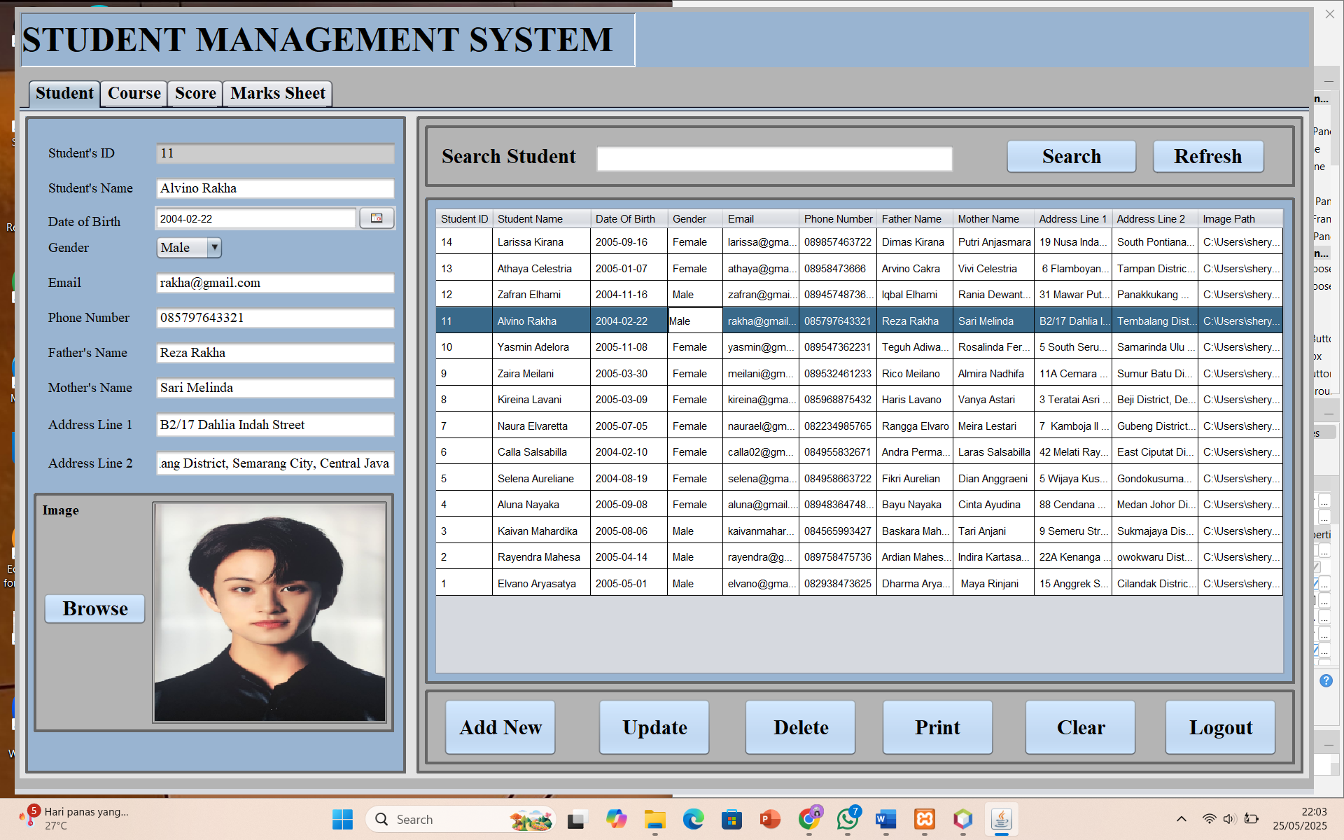

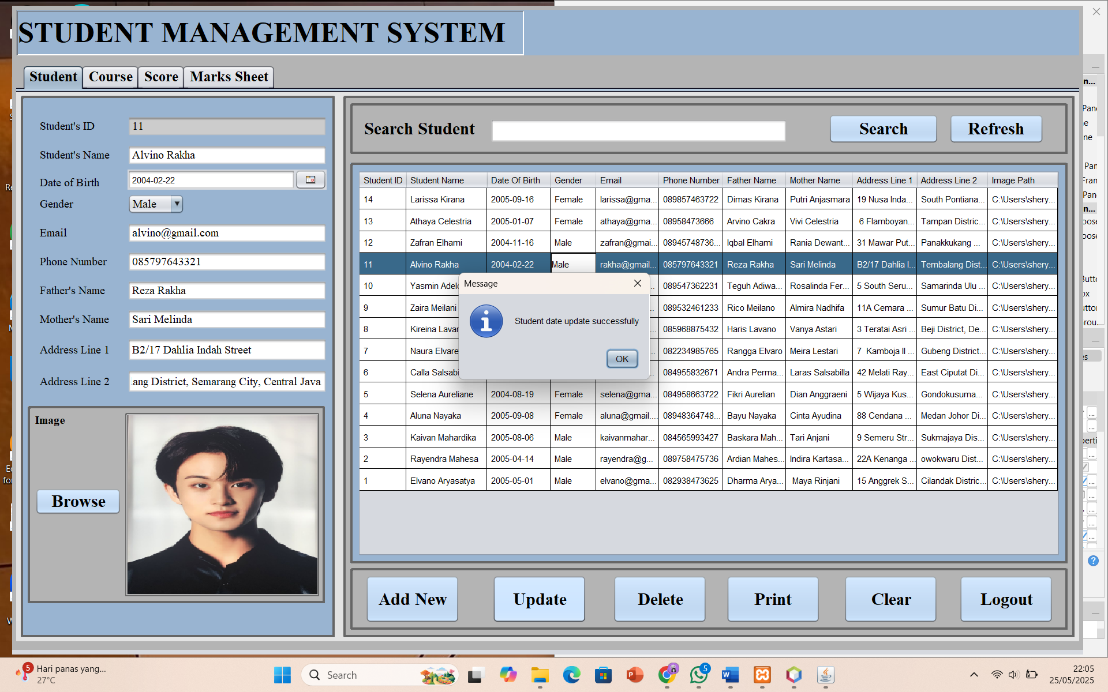

The updated data will be immediately displayed in the table.

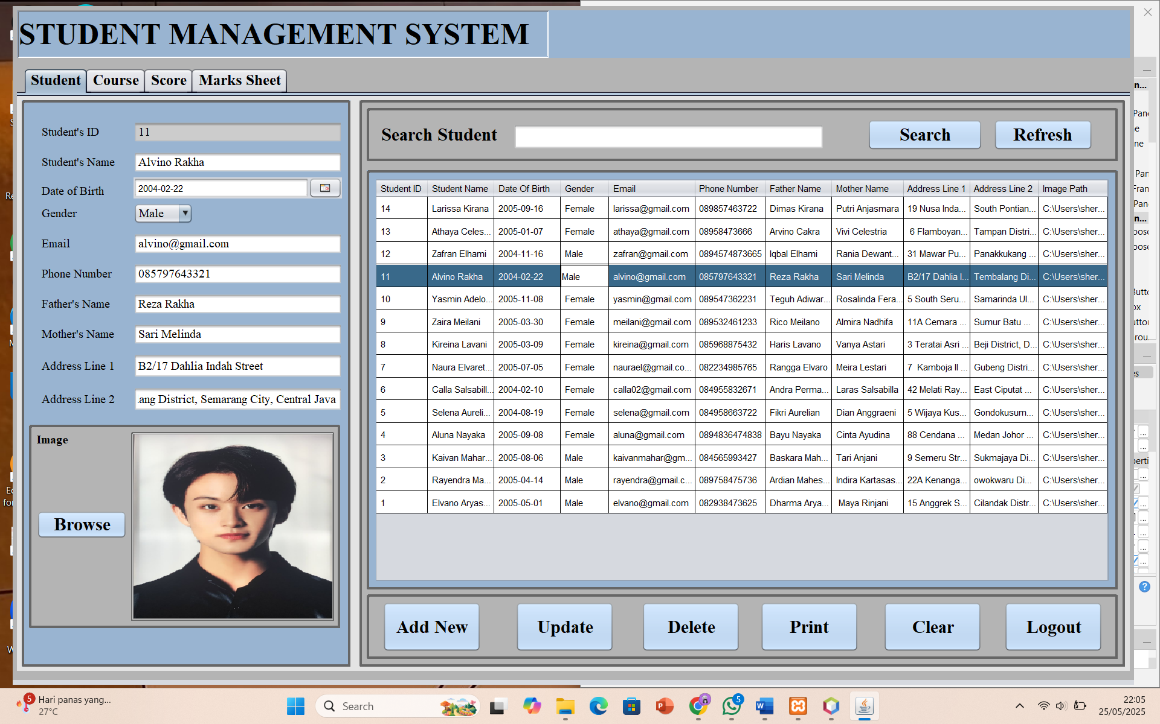

1. DELETE

This delete feature removes existing student data.

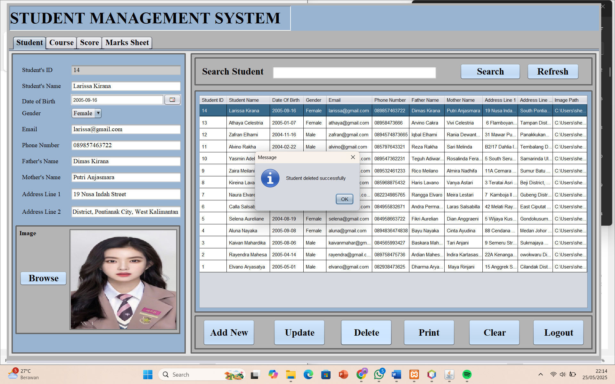

Then it will automatically be deleted from the table as well.

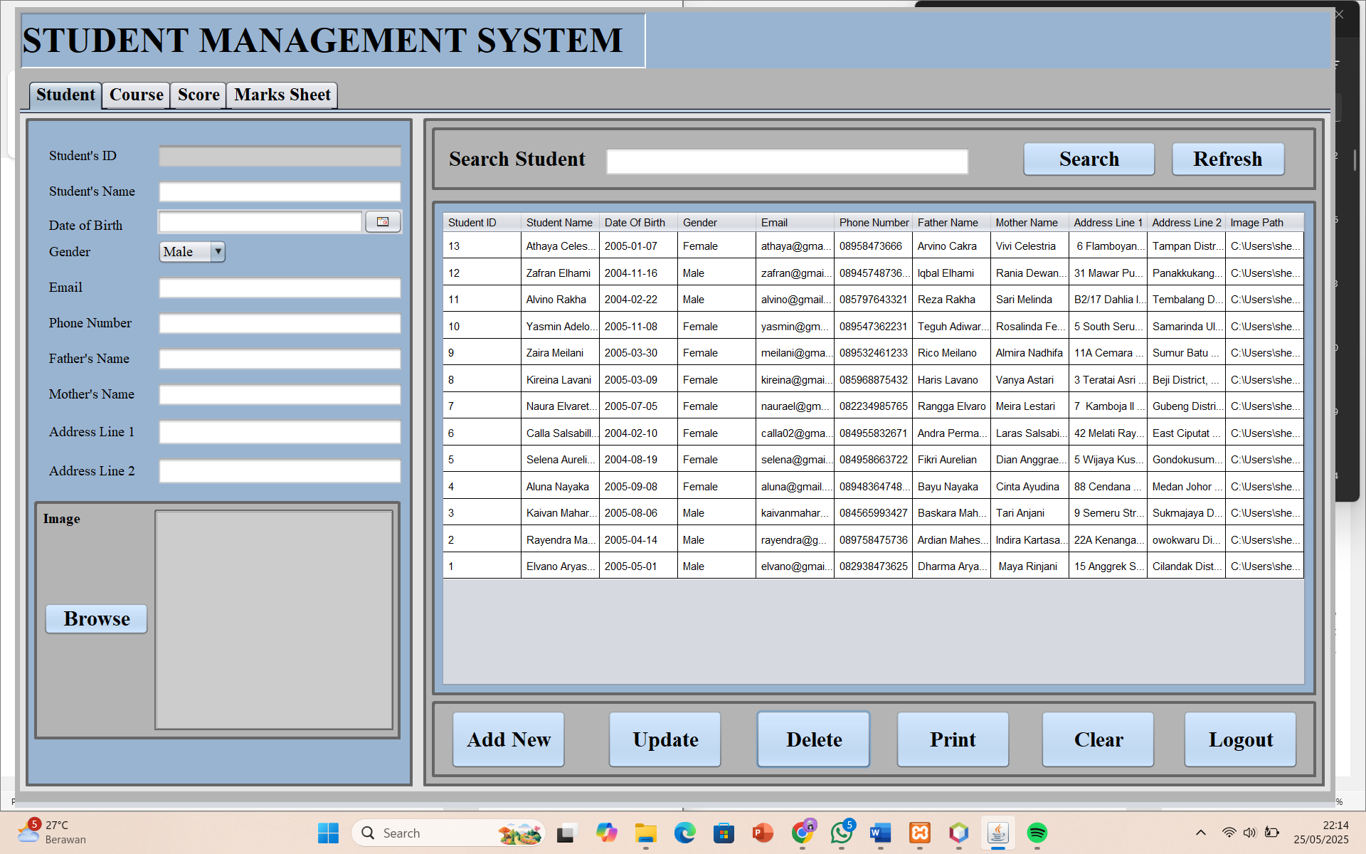

1. PRINT

This print feature is useful for saving data in word or pdf files.

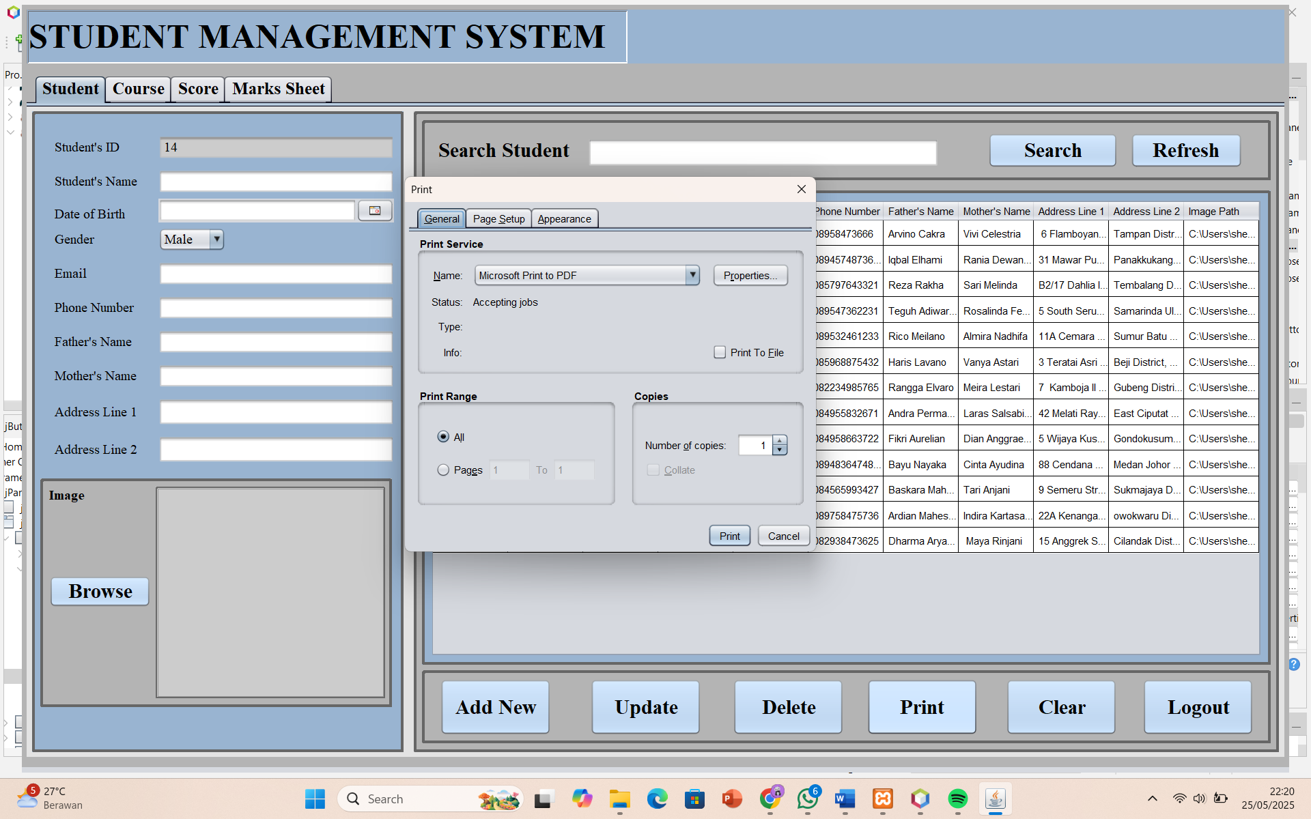

This is how the word file looks like.

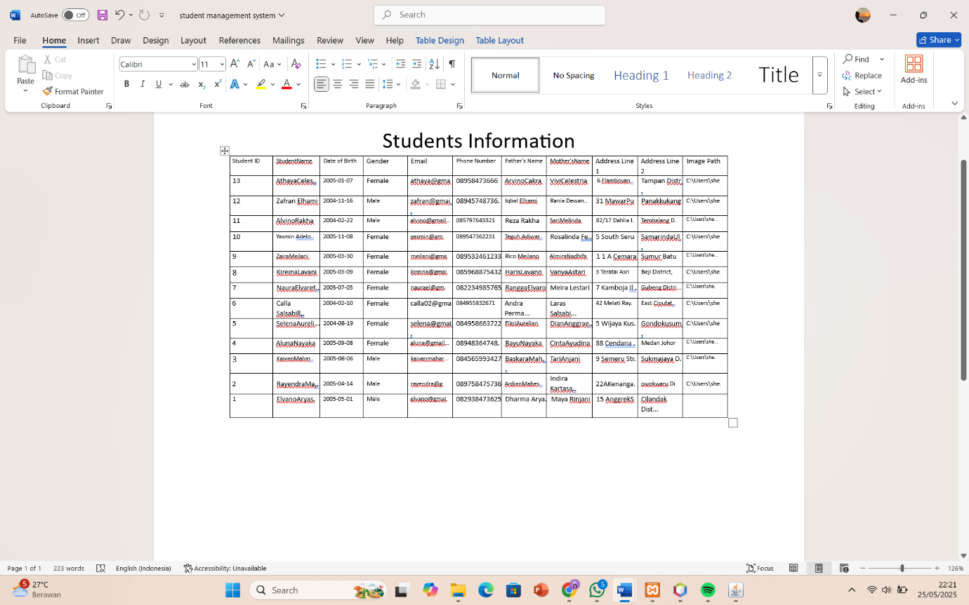

1. CLEAR

The clear feature only clears the form that has been filled in without deleting the existing data. The example can be seen from the two images below.

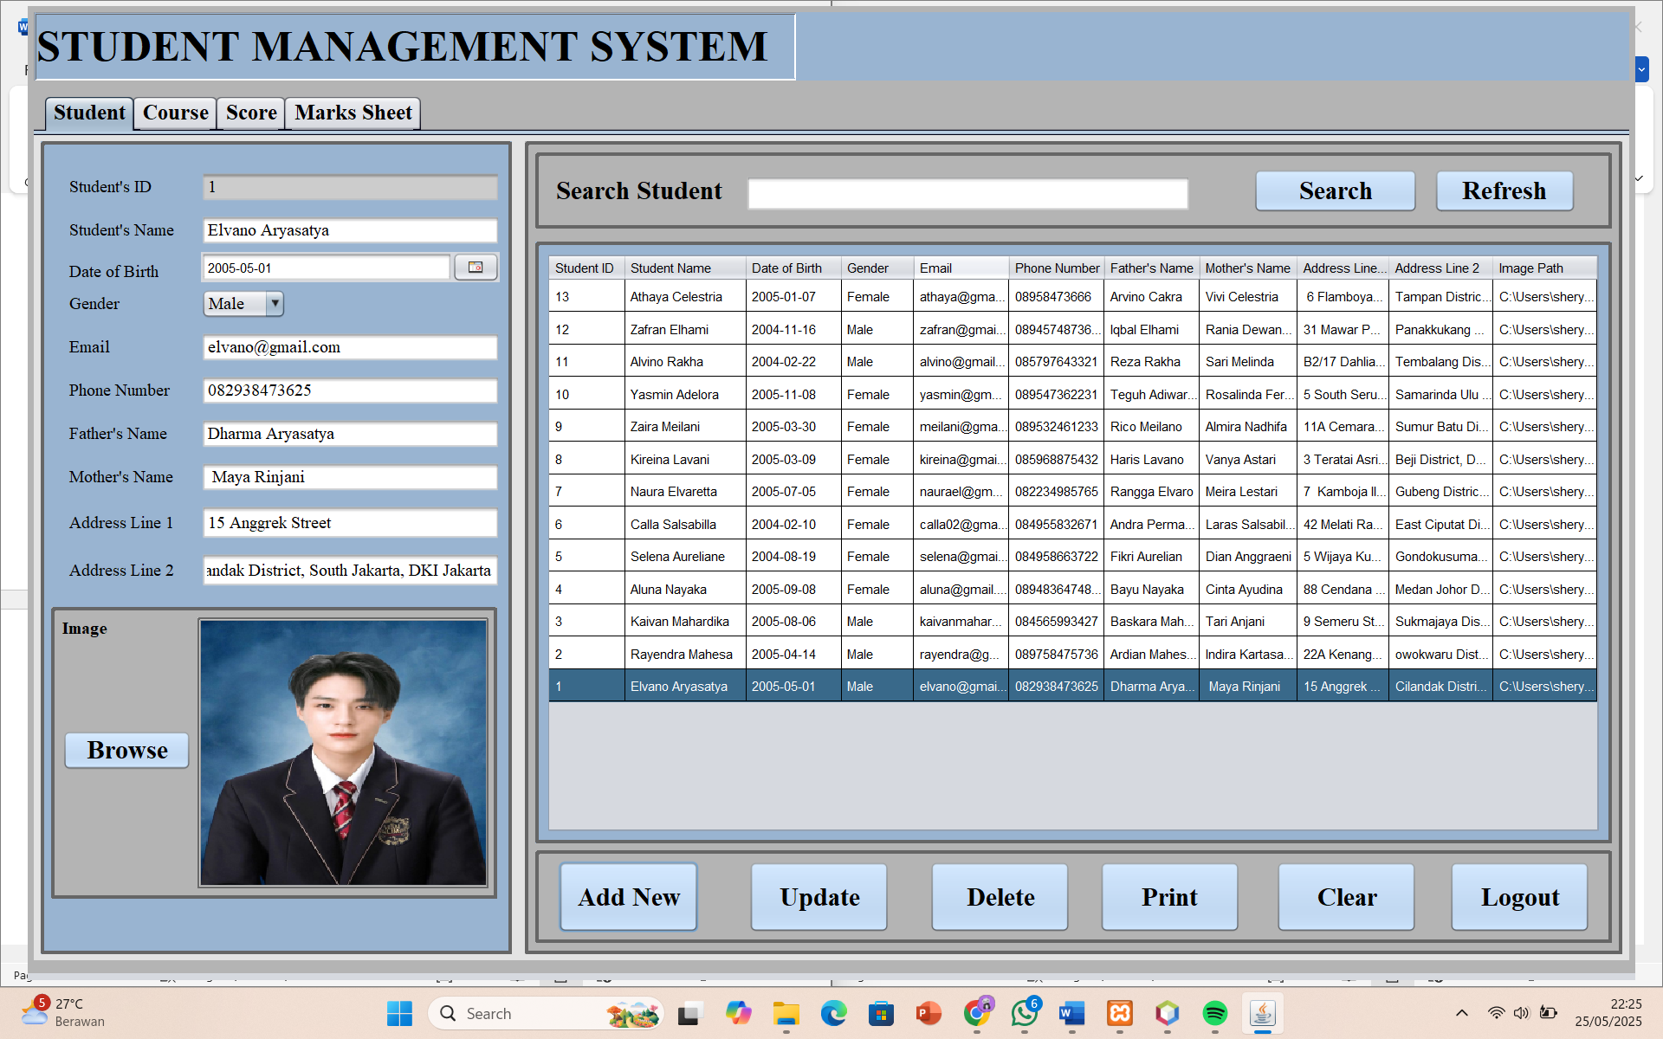

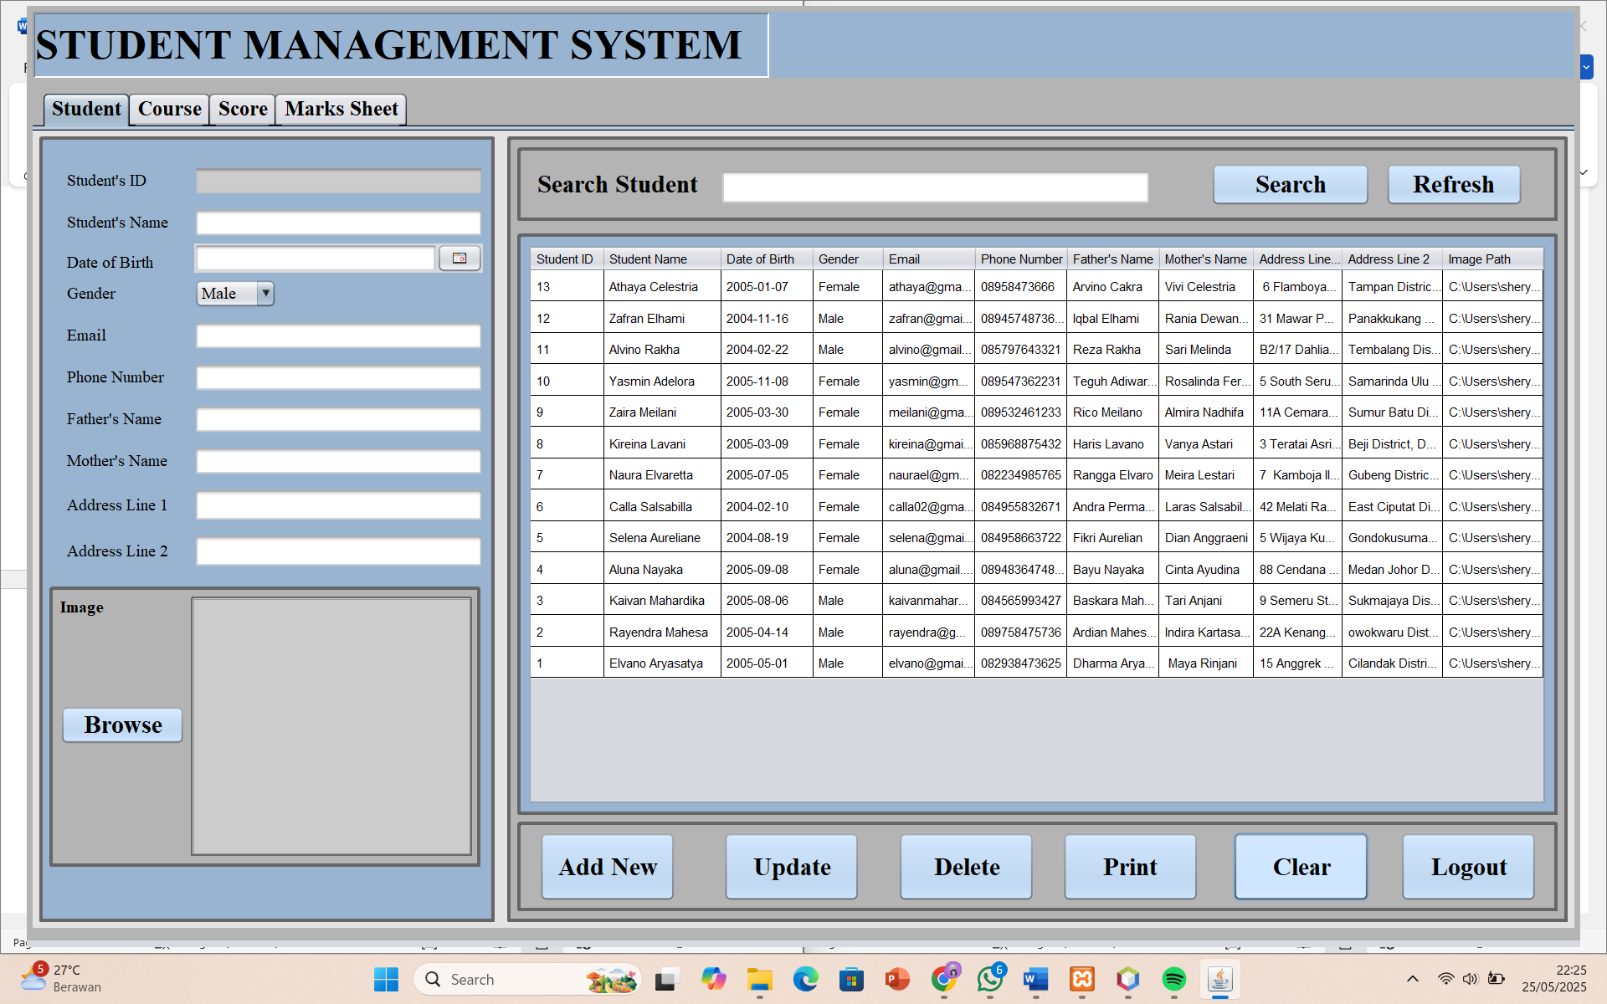

1. LOG OUT

The log out feature to exit the student management page.

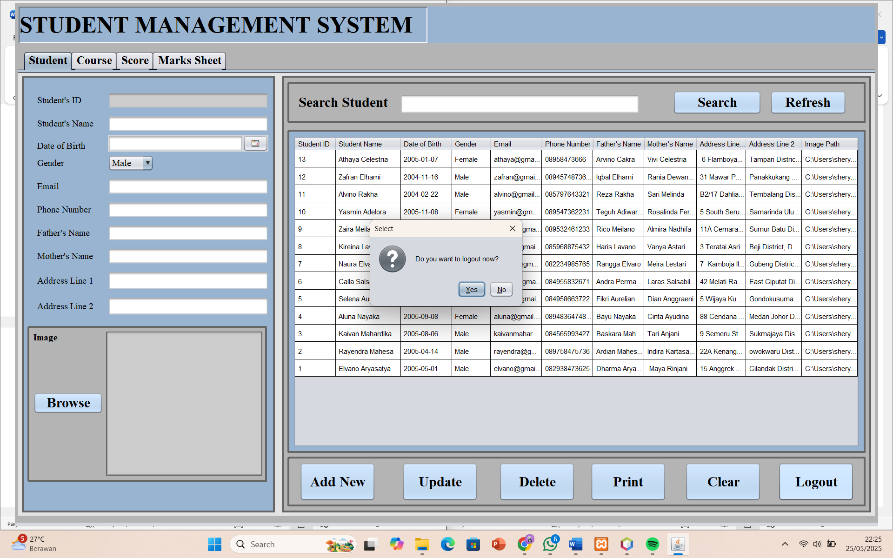

1. SEARCH

There is a search feature to make it easier to find data from certain students by typing the Student ID or Student Name.

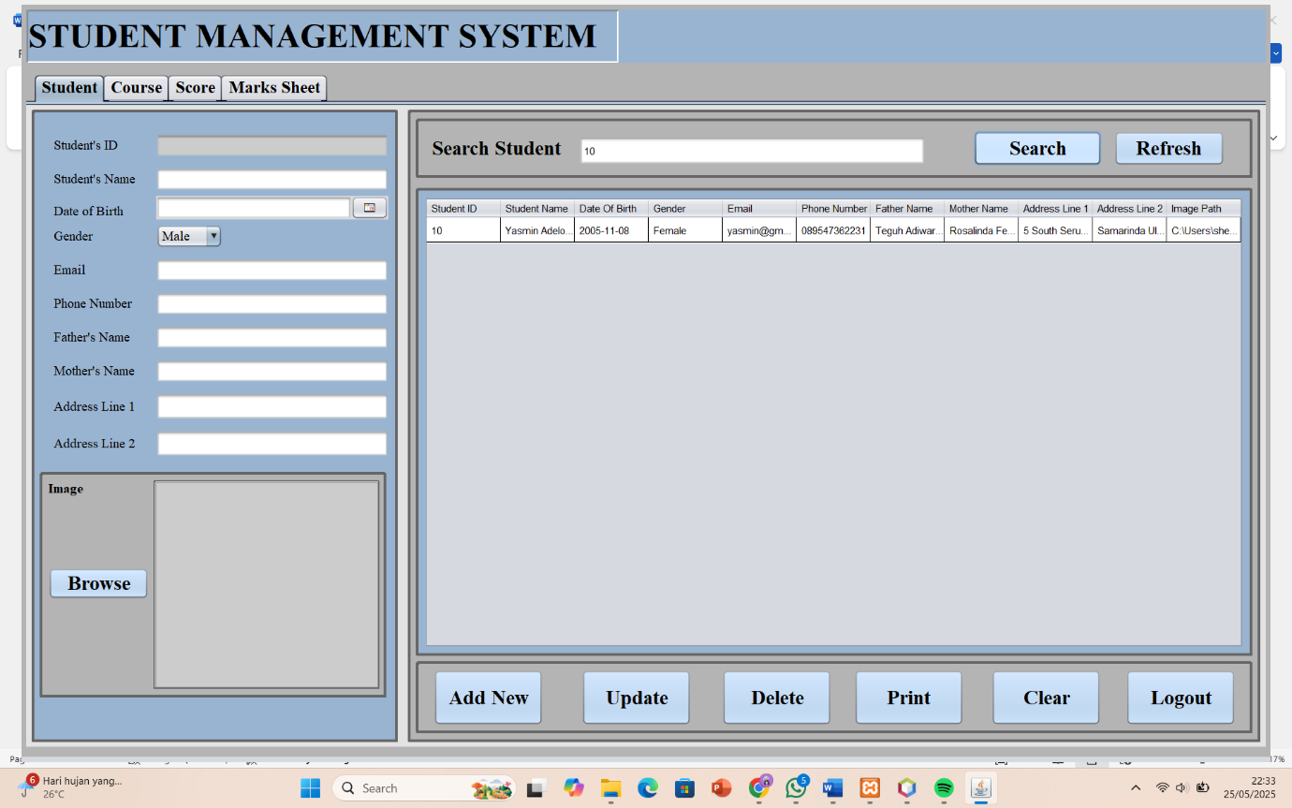

1. REFRESH

After searching, and then click the Refresh button, the table display will change to the original one that displays all student data.

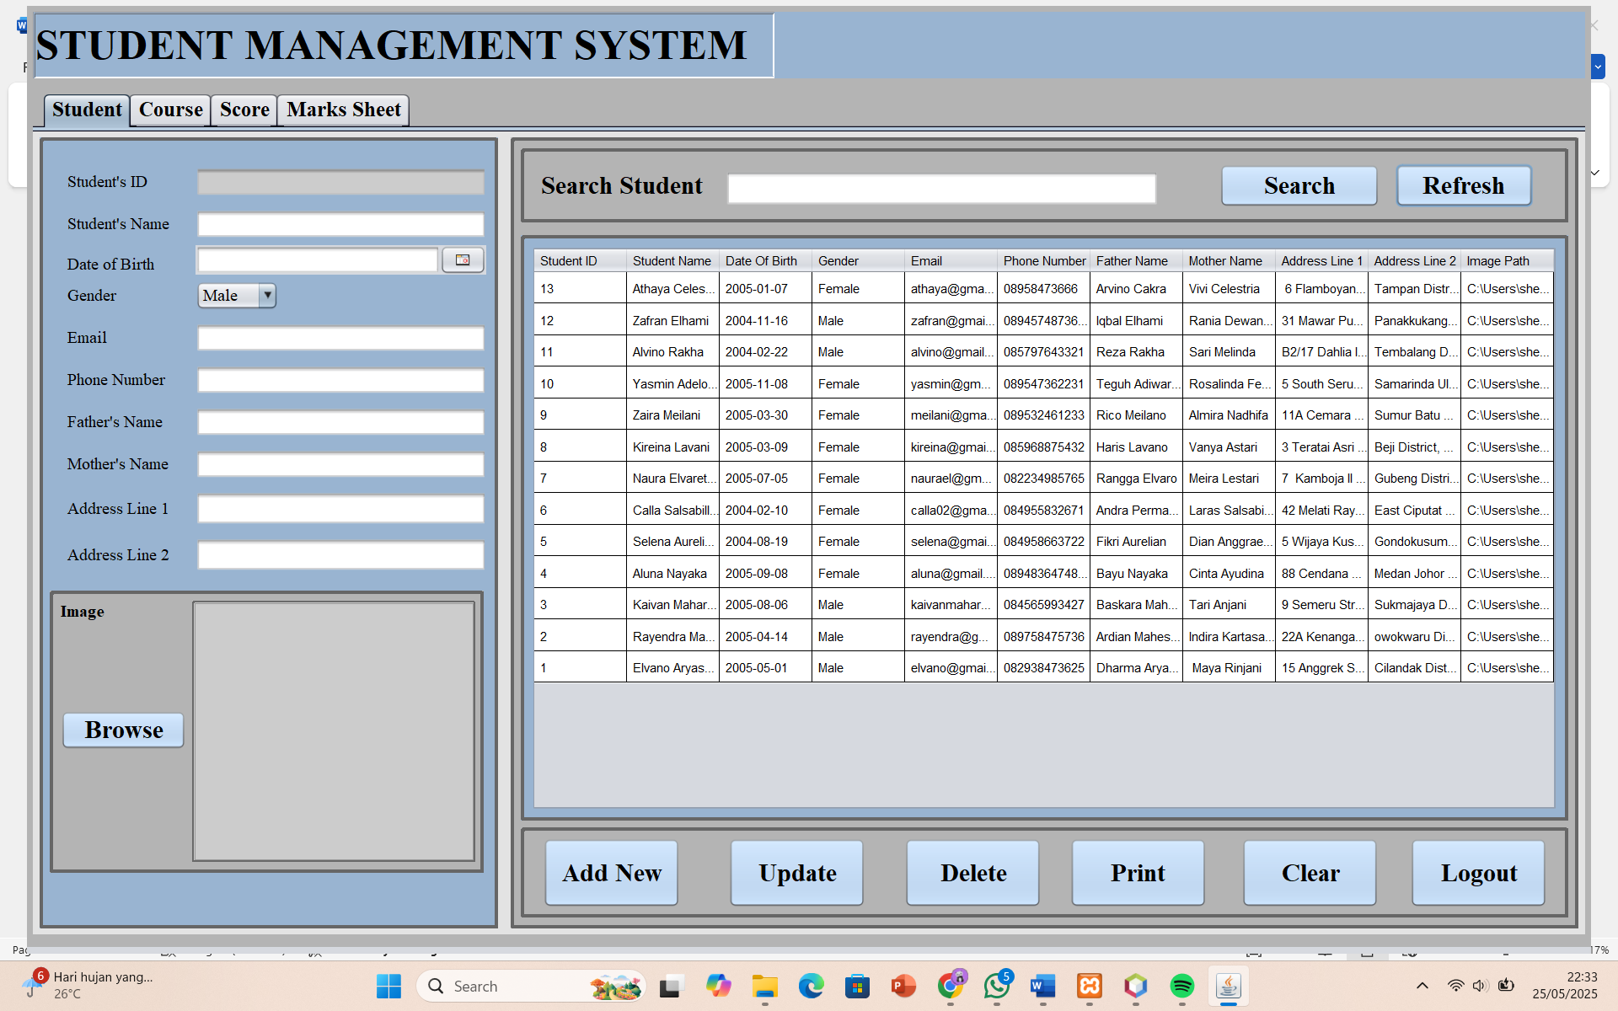

1. **COURSE**

This page allows the admin to manage students’ course enrollments per semester, including adding, viewing, and printing course data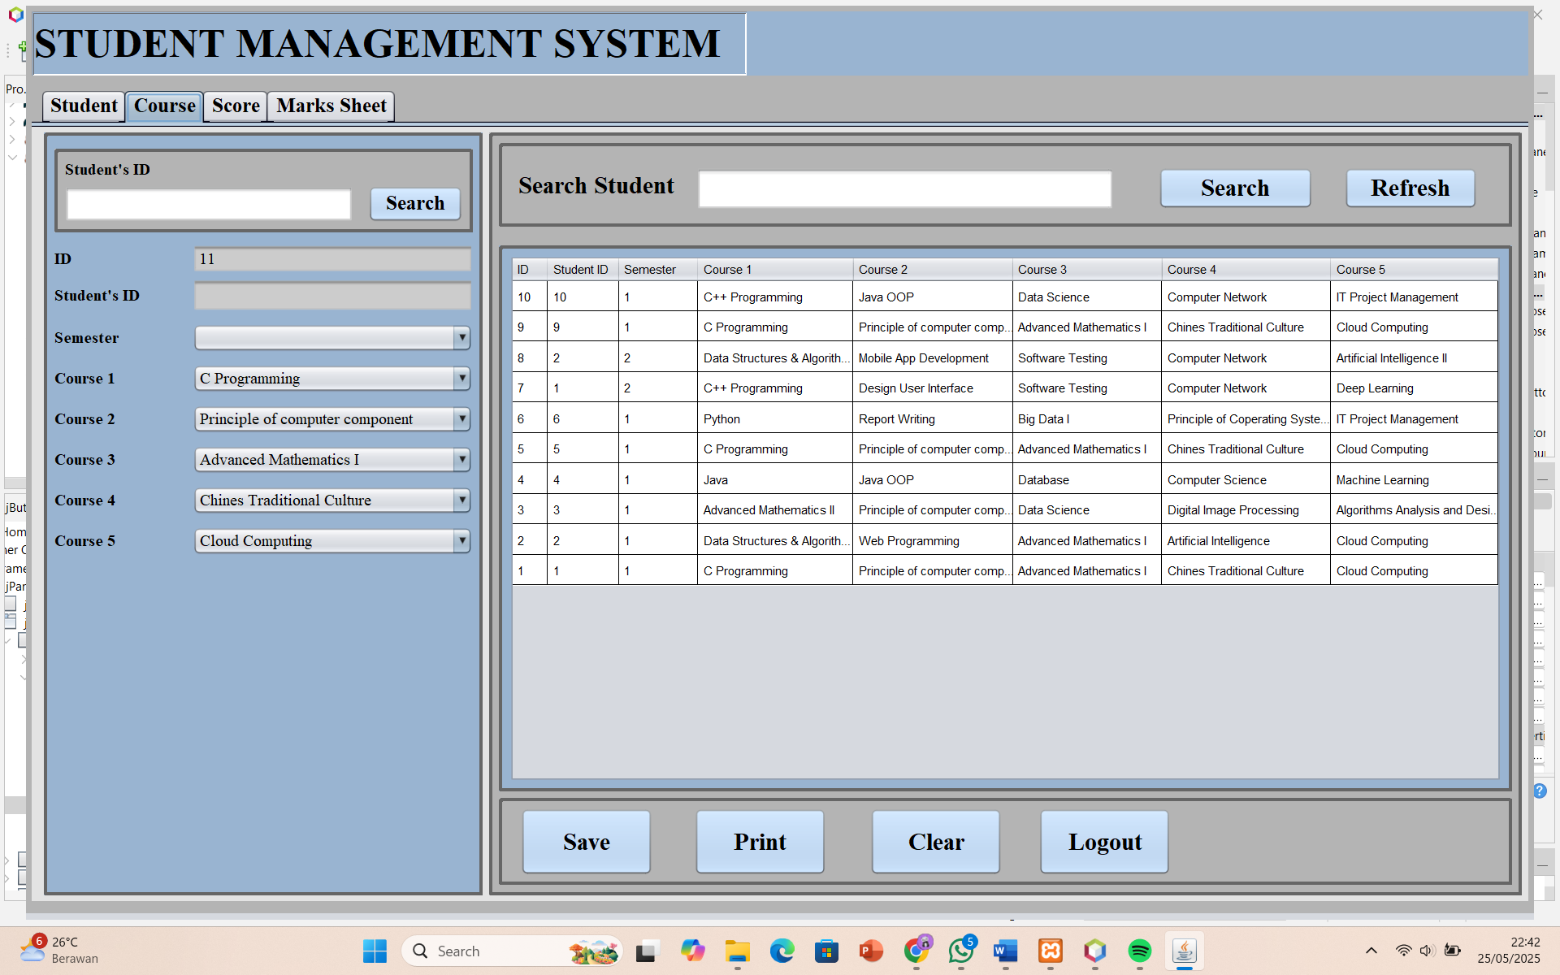

1. SAVE

The save feature is the same as the add new feature on the student page. the difference is that on this page the admin can fill in the student's id, student semester and the course to be taken.

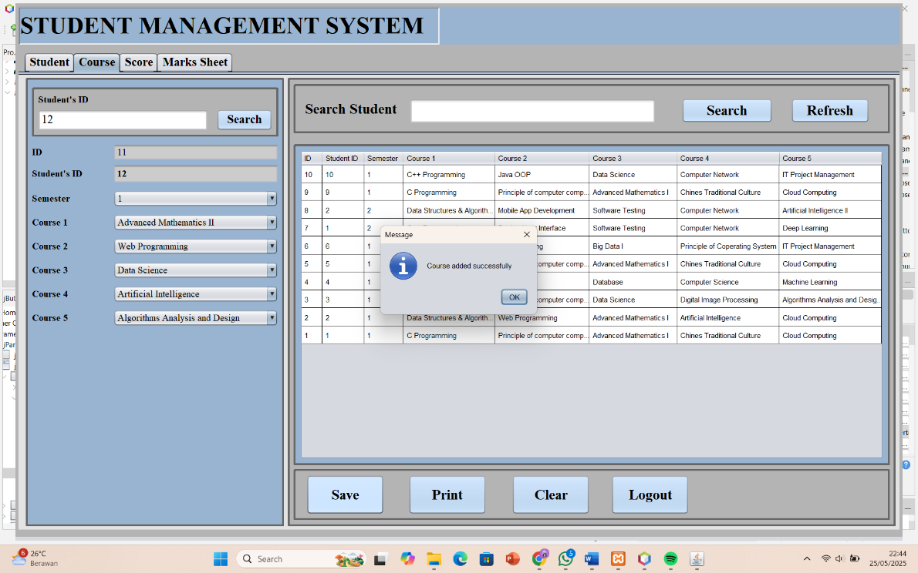

If the student has already taken semester 1, then in the next course the student must choose semester 2.

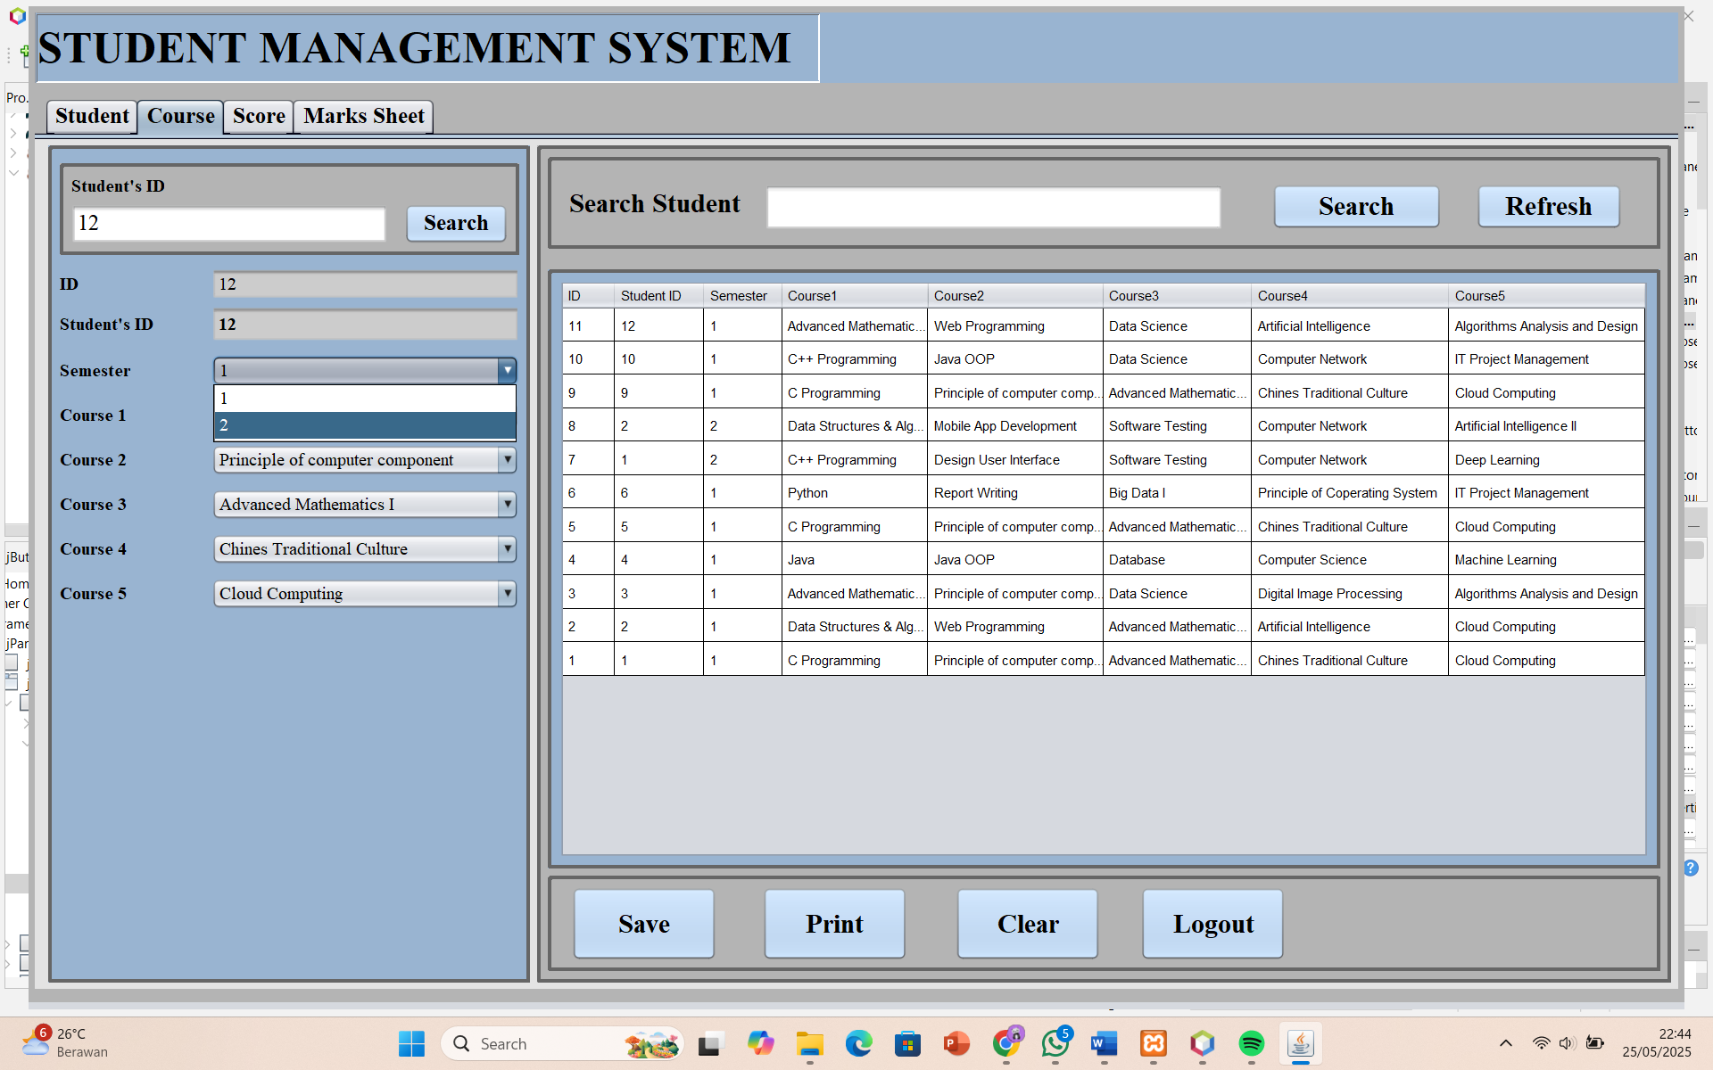

1. PRINT

The print feature on the course page is useful for storing student data, especially the semester and course taken.

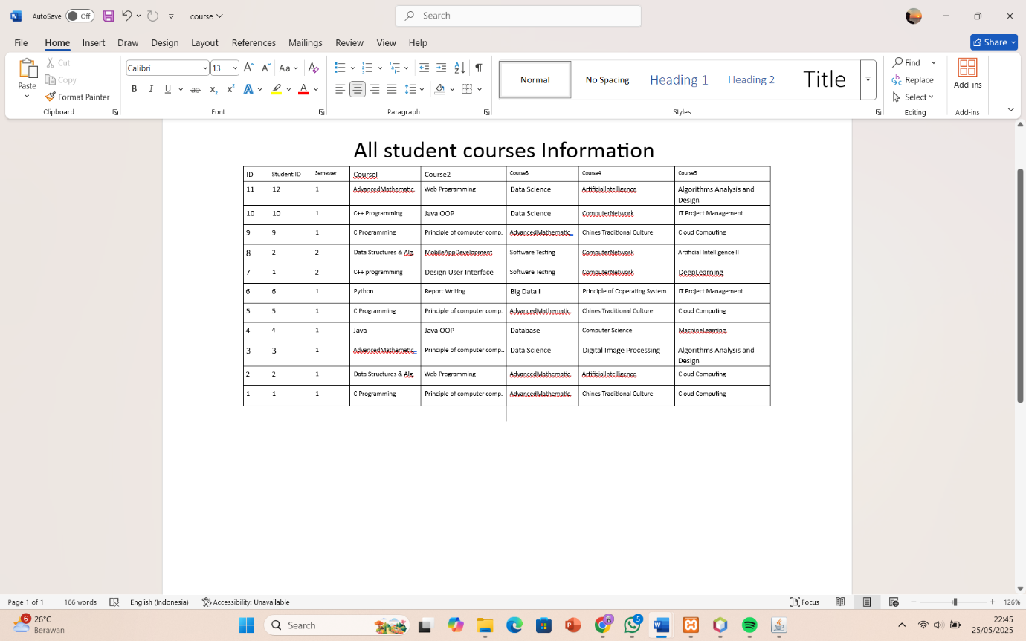

1. SEARCH

Search feature on this course page to make it easier to find course data from certain students.

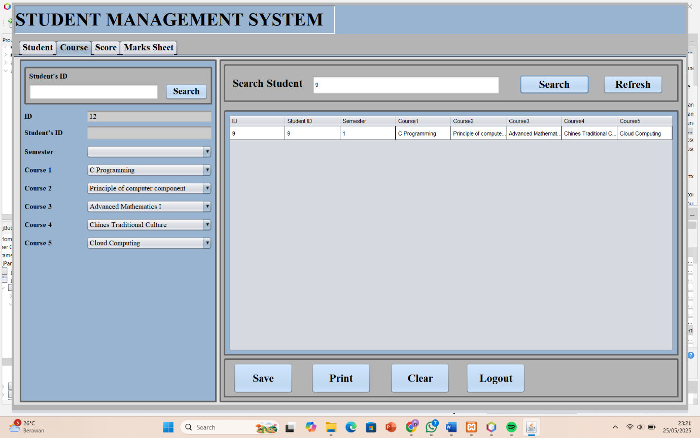

1. REFRESH

After searching, and then click the Refresh button, the table display will change to the original one that displays all the course data.

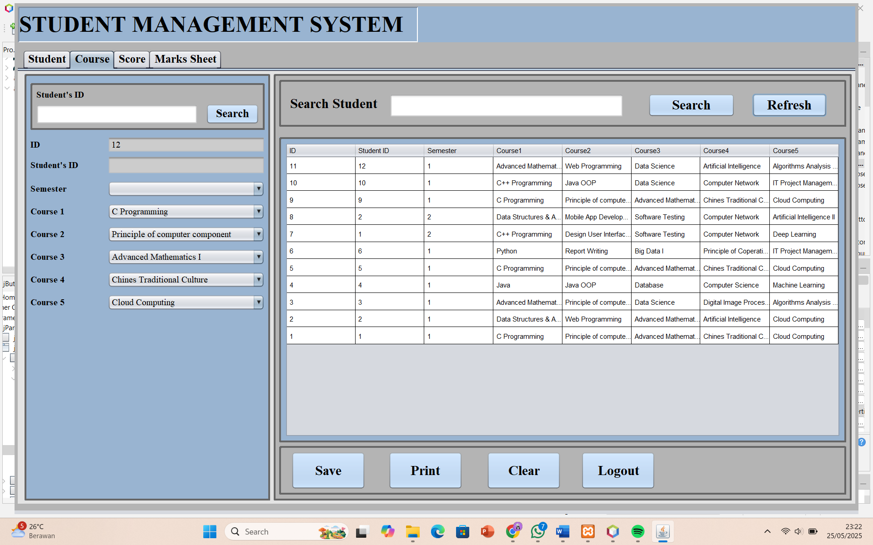

1. **SCORE**
2. SAVE

To add a score to each student's course, the admin must fill in the student's id and semester first, then fill in the score. after that click the save button, the newly inputted score will be immediately visible in the table.

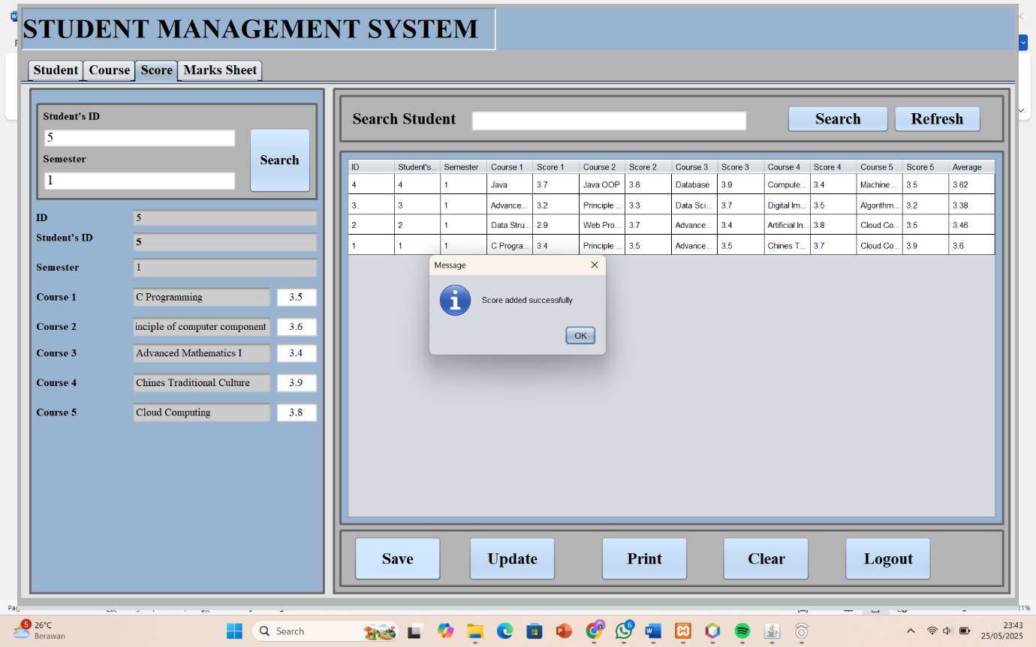

1. UPDATE

The completed score can be changed by clicking the update button.

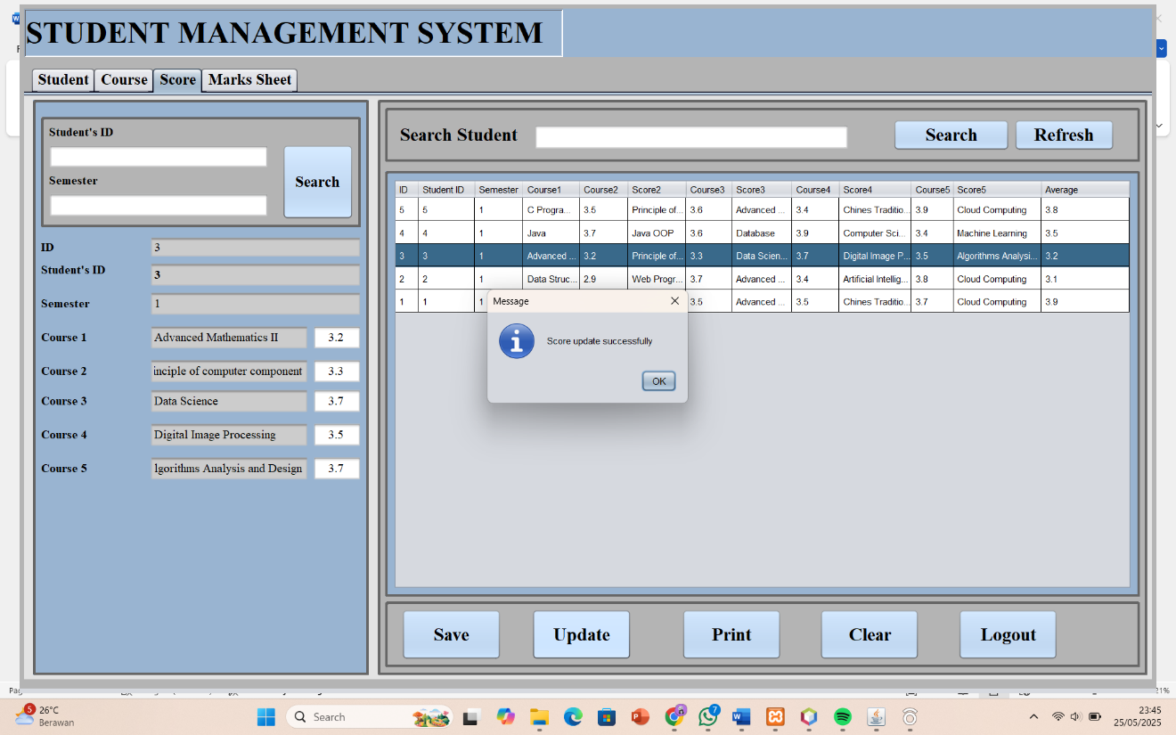

1. PRINT

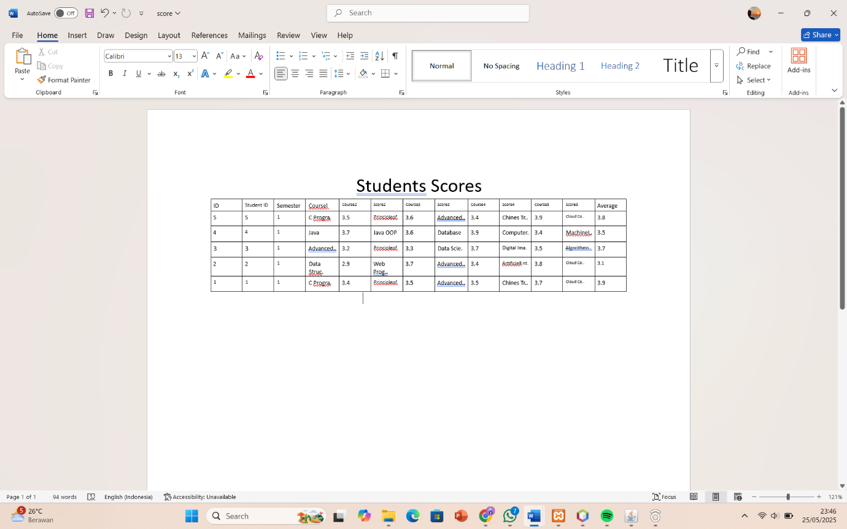

1. SEARCH AND REFRESH

Search feature on the score page to make it easier to find specific student score data, after searching and then click the Refresh button, the table display will change to the original one that displays all the score data.

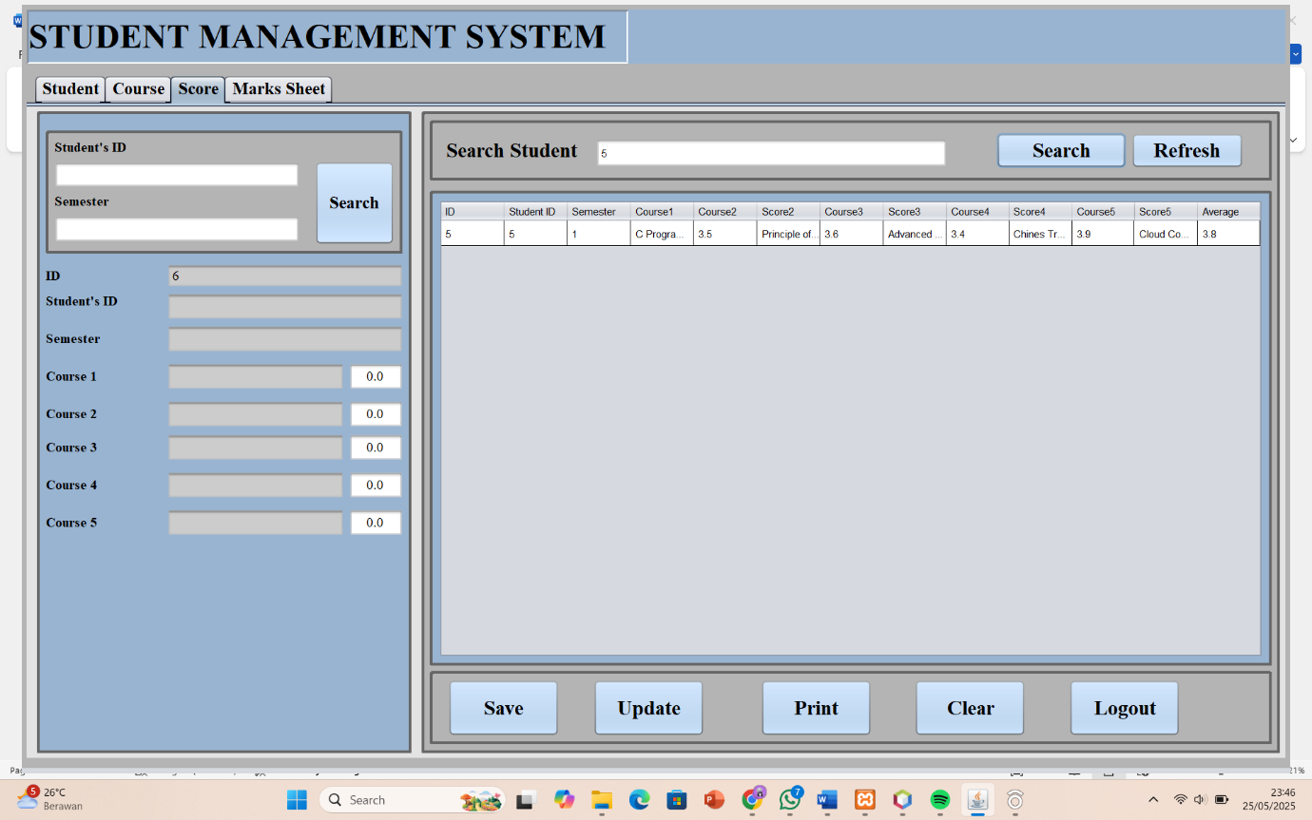

1. **MARKS SHEET**

On the marks sheet page, just enter the Student's ID and click search, the table will immediately display the course and score obtained by the student along with the averagenya, there is also a student's CGPA on the bottom left.

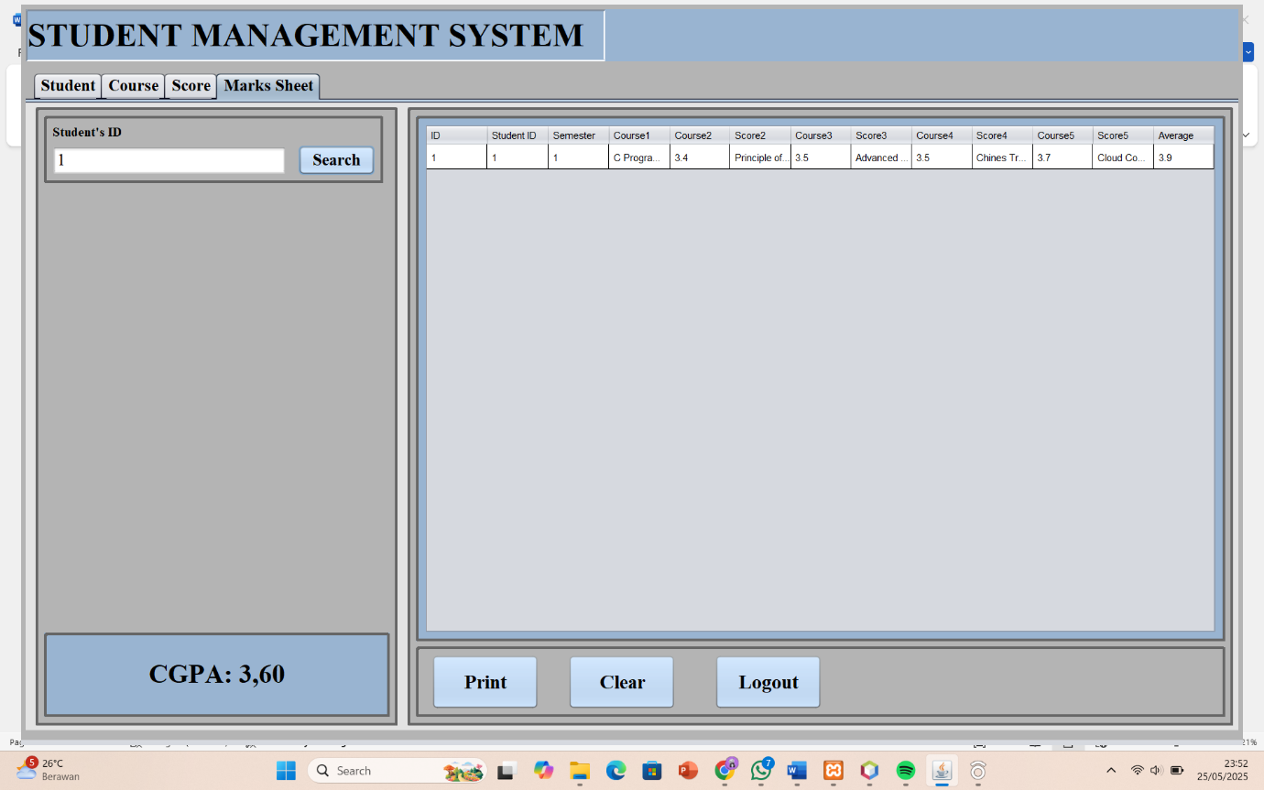

1. PRINT

This is how it looks if admin want to save the data in word after pressing the print button.

